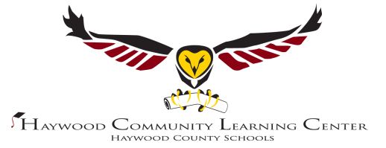

Dear Parent or Guardian,
The 21st Century Haywood Community Learning Center is dedicated to promoting academic achievement. We rely on support from you and our community to help us ensure that your child is making progress toward graduation.
Currently this student is active and demonstrates adequate progress in the following courses
1.
2.
3.
4.
5.
This student could use some improvement in the following courses
1.
2.
3.
Number of credits needed to graduate
1. Math
2. English
3. Social Studies
4. Science
5. Electives
Students at the 21st Century Haywood Community Learning Center are expected to participate in a minimum of 30 enrichment activities throughout the academic school year. 21st CCLC activities are scheduled from 12:45 to 3:15.
Your child has/has not demonstrated satisfactory participation in 21st Century learning activities.

Have you noticed an improvement in your child’s participation in school activities since becoming a student at HCLC?

Please let us know about this child’s hobbies, interests, or anything that might help us prepare him/her for job placement or higher education.

Would you like to schedule an appointment? If so please give us your contact information and indicate your availability for meeting with (circle one) teachers/administrator. Please return in stamped envelope
Thank you so much for taking time to fill out this questionnaire! We are always available for your questions or suggestions and welcome your participation in helping us to shape your child’s future!
Please check our Website for news and events: http://www.clc.haywood.k12.nc.us/
Kyle W. Ledford Caroline Brown Williamsom
HCLC Executive Director 21st CCLC HCLC Program Director

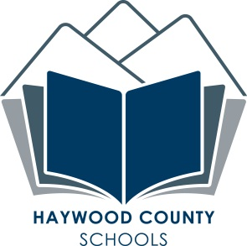
828-454-6590

